**Employee Management System**

| **Operation** | **Time Complexity** | **Explanation** |
| --- | --- | --- |
| **Add** | O(1) | Add at next available index. |
| **Search** | O(n) | Linear search for ID. |
| **Traverse** | O(n) | Visit each employee. |
| **Delete** | O(n) | Search + shift elements. |

**CODE:**

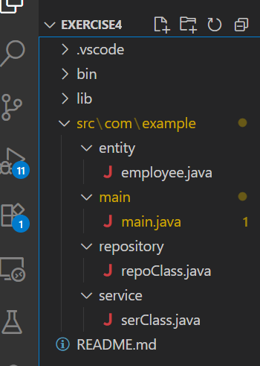

Employee.java

package com.example.entity;

public class employee {

private int empId;

private String name;

private String position;

private double salary;

public employee(int empId, String name, String position, double salary) {

this.empId = empId;

this.name = name;

this.position = position;

this.salary = salary;

}

public int getEmpId() {

return empId;

}

public void setEmpId(int empId) {

this.empId = empId;

}

public String getName() {

return name;

}

public void setName(String name) {

this.name = name;

}

public String getPosition() {

return position;

}

public void setPosition(String position) {

this.position = position;

}

public double getSalary() {

return salary;

}

public void setSalary(double salary) {

this.salary = salary;

}

}

main.java :

package com.example.main;

import java.util.Scanner;

import com.example.entity.employee;

import com.example.service.serClass;

public class main {

private static serClass ser = new serClass();

private static Scanner sc = new Scanner(System.in);

private static main main = new main();

public static void main(String args[]) {

boolean flag = true;

while (flag) {

System.out.println();

System.out.println("EMPLOYEE MANAGEMENT SYSTEM : ");

System.out.println();

System.out.println("1. Add user");

System.out.println("2. Search user by id");

System.out.println("3. Traverse / Display all users");

System.out.println("4. Delete user by id");

System.out.println("5. Exit");

System.out.println();

System.out.print("Enter your choice = ");

int n = sc.nextInt();

sc.nextLine();

System.out.println();

switch (n) {

case 1:

main.adduser();

break;

case 2:

main.searchUser();

break;

case 3:

main.display();

break;

case 4:

main.delete();

break;

case 5:

flag = false;

break;

default:

break;

}

}

}

private void adduser() {

System.out.print("Enter the userId = ");

int id = sc.nextInt();

sc.nextLine();

System.out.print("Enter the name = ");

String name = sc.nextLine();

System.out.print("Enter the position = ");

String position = sc.nextLine();

System.out.print("Enter the salary = ");

double salary = sc.nextDouble();

System.out.println();

employee emp = new employee(id, name, position, salary);

ser.adduser(emp);

}

private void searchUser() {

System.out.print("Enter the user id to find = ");

int n = sc.nextInt();

sc.nextLine();

System.out.println();

ser.searchUser(n);

}

private void display() {

ser.display();

}

private void delete() {

System.out.print("Enter the id to delete = ");

int n = sc.nextInt();

sc.nextLine();

System.out.println();

ser.delete(n);

}

}

repoClass.java :

package com.example.repository;

import com.example.entity.employee;

public class repoClass {

private employee[] employees;

private int count;

public repoClass() {

employees = new employee[10];

count = 0;

}

private boolean isDupli(int id) {

for (int i = 0; i < count; i++) {

if (employees[i].getEmpId() == id) {

return true;

}

}

return false;

}

public void adduser(employee e) {

if (count >= employees.length) {

System.out.println("Employee list is full..");

System.out.println();

return;

} else if (isDupli(e.getEmpId())) {

System.out.println("Employee already exist..");

System.out.println();

return;

}

employees[count++] = e;

System.out.println("Successfully added..");

System.out.println();

}

public void searchUser(int id) {

for (int i = 0; i < count; i++) {

if (employees[i].getEmpId() == id) {

System.out.println("ID Found : ");

;

System.out.println(

"Id = " + employees[i].getEmpId() + "\t Name = " + employees[i].getName() + "\t Position = "

+ employees[i].getPosition() + "\t Salary = " + employees[i].getSalary());

return;

}

}

System.out.println("Id not Found..");

}

public void display() {

if (count == 0) {

System.out.println("Employee list is empty!!...");

} else {

System.out.println("Id \t Name \t Position \t Salary");

System.out.println("--------------------------------------------");

for (int i = 0; i < count; i++) {

System.out.println(employees[i].getEmpId() + "\t" + employees[i].getName() + "\t"

+ employees[i].getPosition() + "\t" + employees[i].getSalary());

}

}

}

public void delete(int id) {

int index = -1;

for (int i = 0; i < count; i++) {

if (employees[i].getEmpId() == id) {

index = i;

break;

}

}

if (index == -1) {

System.out.println("Employee ID not found...");

return;

}

for (int i = index; i < count - 1; i++) {

employees[i] = employees[i + 1];

}

employees[--count] = null;

System.out.println("Employee Id " + id + " successfully deleted.");

}

}

serClass.java

package com.example.service;

import com.example.entity.employee;

import com.example.repository.repoClass;

public class serClass {

private static repoClass repo = new repoClass();

public void adduser(employee e) {

repo.adduser(e);

}

public void searchUser(int id) {

repo.searchUser(id);

}

public void display() {

repo.display();

}

public void delete(int id) {

repo.delete(id);

}

}

## **Output :**

|  |  |
| --- | --- |
|  |  |